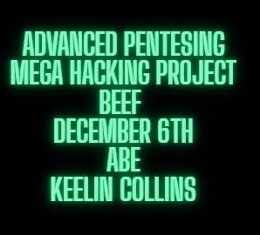

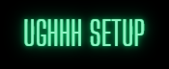
First step of the radical hacking project that is beef is to set up two Kali VMS with host only interfaces.
Set static ips on host only network interfaces with command
sudo nano /etc/network/interfaces
Inside the interfaces document add
auto eth0
iface eth0 inet static
address [whatever ip you would like]
netmask [whatever netmask you would like]
Save and exit the interfaces file and then
sudo systemctl restart Networking
Your new incredible hacker ips should now be set when you run
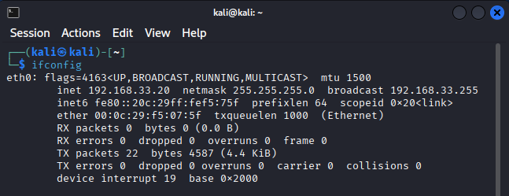
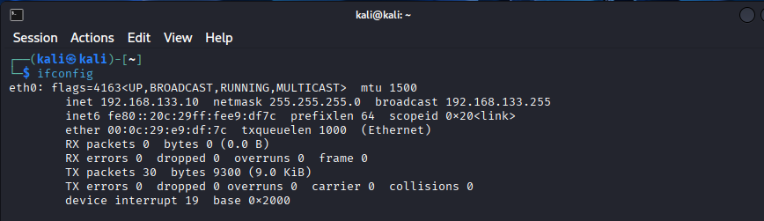
Ipconfig

On the Attacking VM complete the following steps to start your journey of world domination.
Install and start beef xss with the following commands.
Sudo apt install beef-xss
Start beef-xss
sudo systemctl start beef-xss
The default passwords must be changed so edit the config file and change values under credentials:
sudo nano /etc/beef-xss/config.yaml
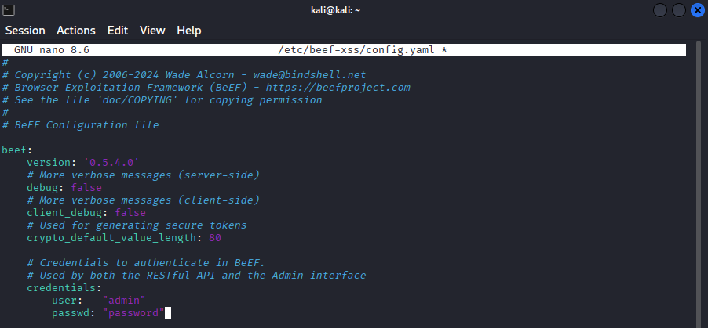
Okay now your one step closer, open Firefox go to the login page
http://localhost:3000/ui/panel

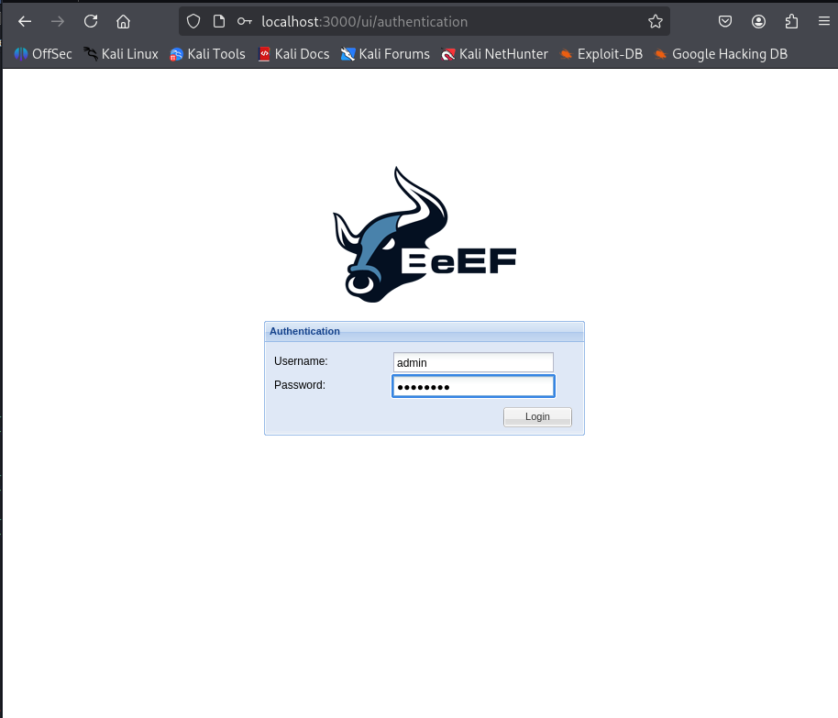
Login with the new credentials that were just changed in the configuration file

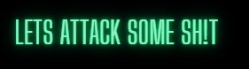
Create a diabolical .html file with the beef hook script embedded in.
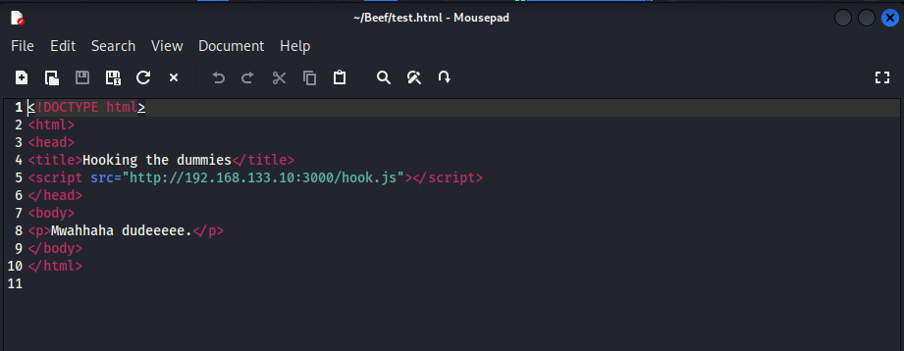
Start an http server to host the file with the following steps:
Create html file above, save in a separate folder.
cd into that folder and run
python -m http.server 8080

The moronic victim VM will then browse to
http:// [Attacking VM IP]:8080/[Name of your .html file]

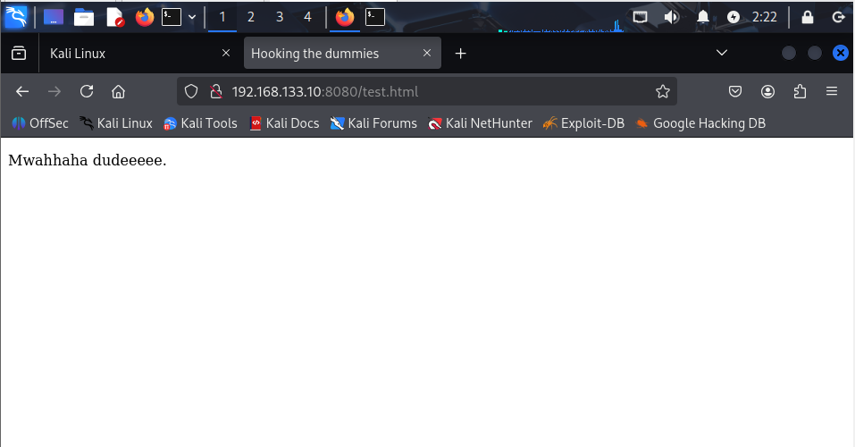
And *evil laugh* you’ve got their sorry as$es.

Go back to the Attacking VM and browse to the main beef page at
http://localhost:3000/ui/panel
Under Online Browsers you should now see the IP of your moronic Victim VM machine.
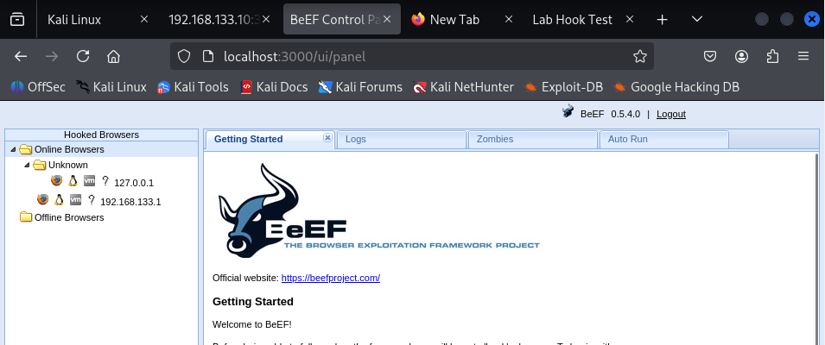
Click the ip of your Victim VM and go to Commands there is a long list of commands that can be run against the machine, and just go crazy, try them all, or if you don’t care about being super cool don’t.
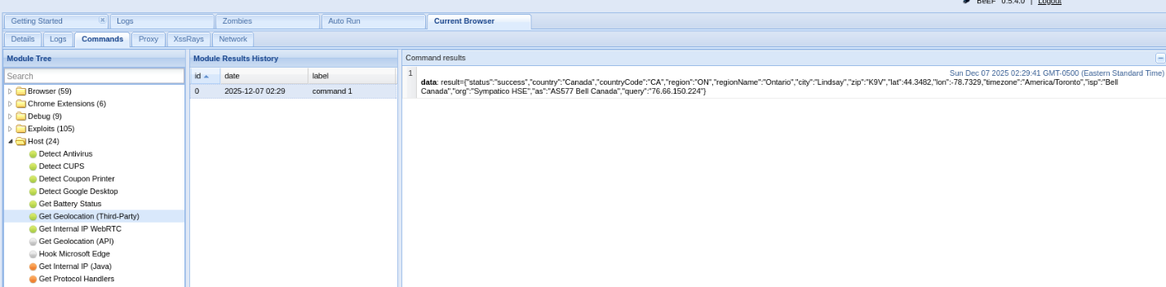
This one find the geolocation of the Victim…. spooky.
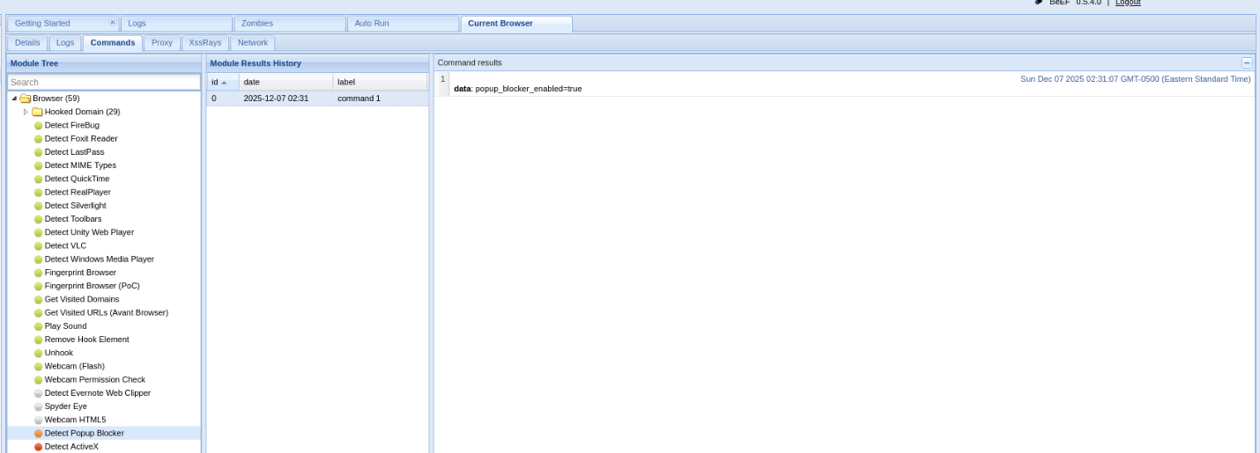
This one checks if there browser blocks popup…. Not very spooky but cool. 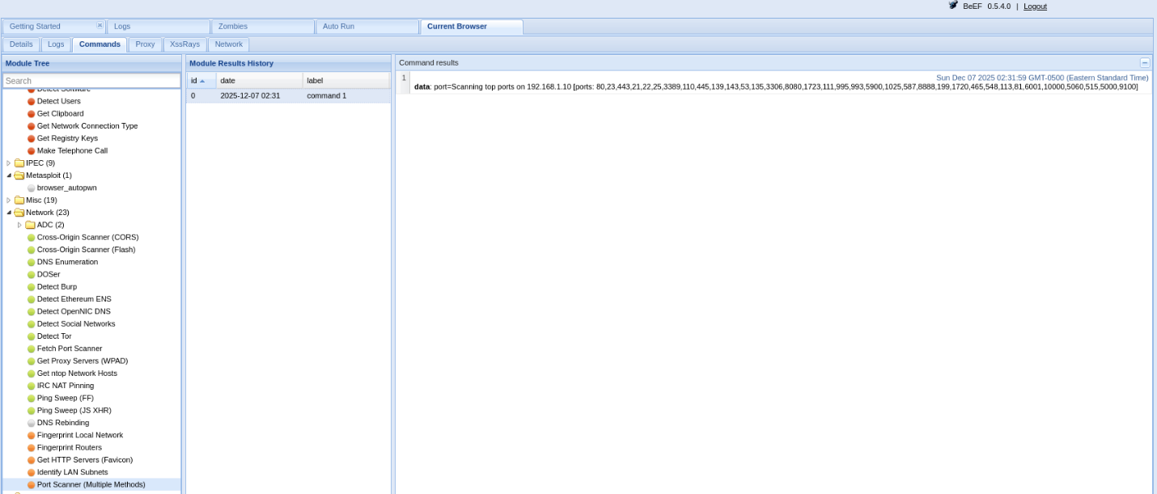
This one checks all the open ports….. very spooky.

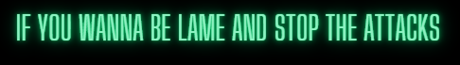
Install No Script as an addon onto the browser (in this case firefox). The page will still load but the script hook.js script will not be allowed to run, go back to the beef home page and you should see that your Victims IP address is no longer avaliable under online browsers.
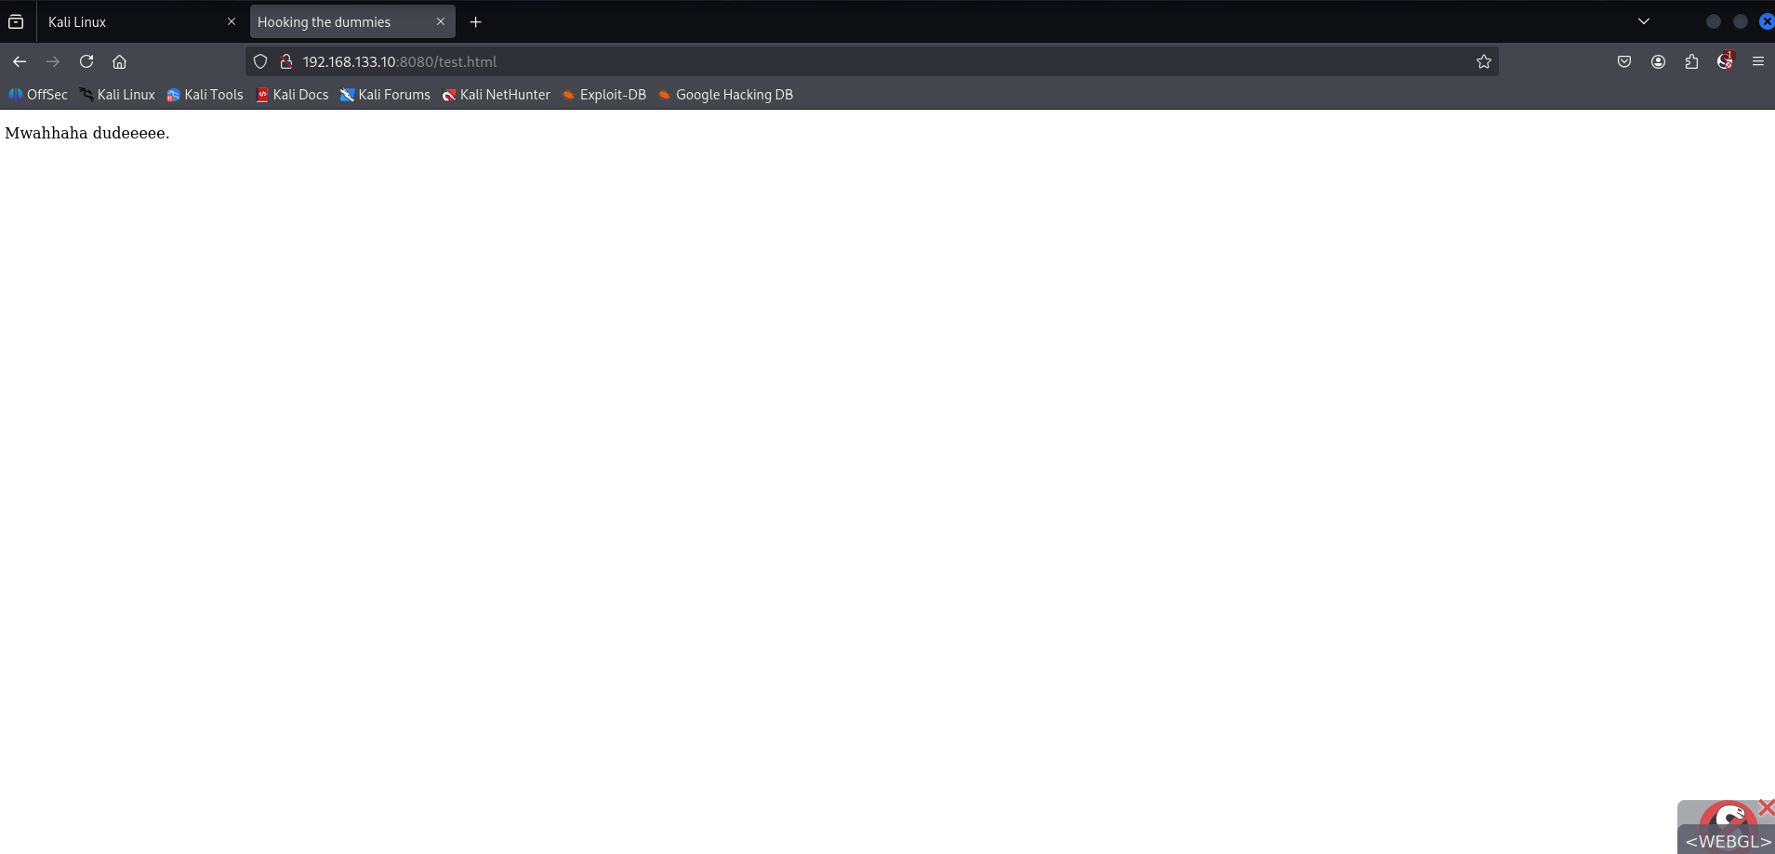
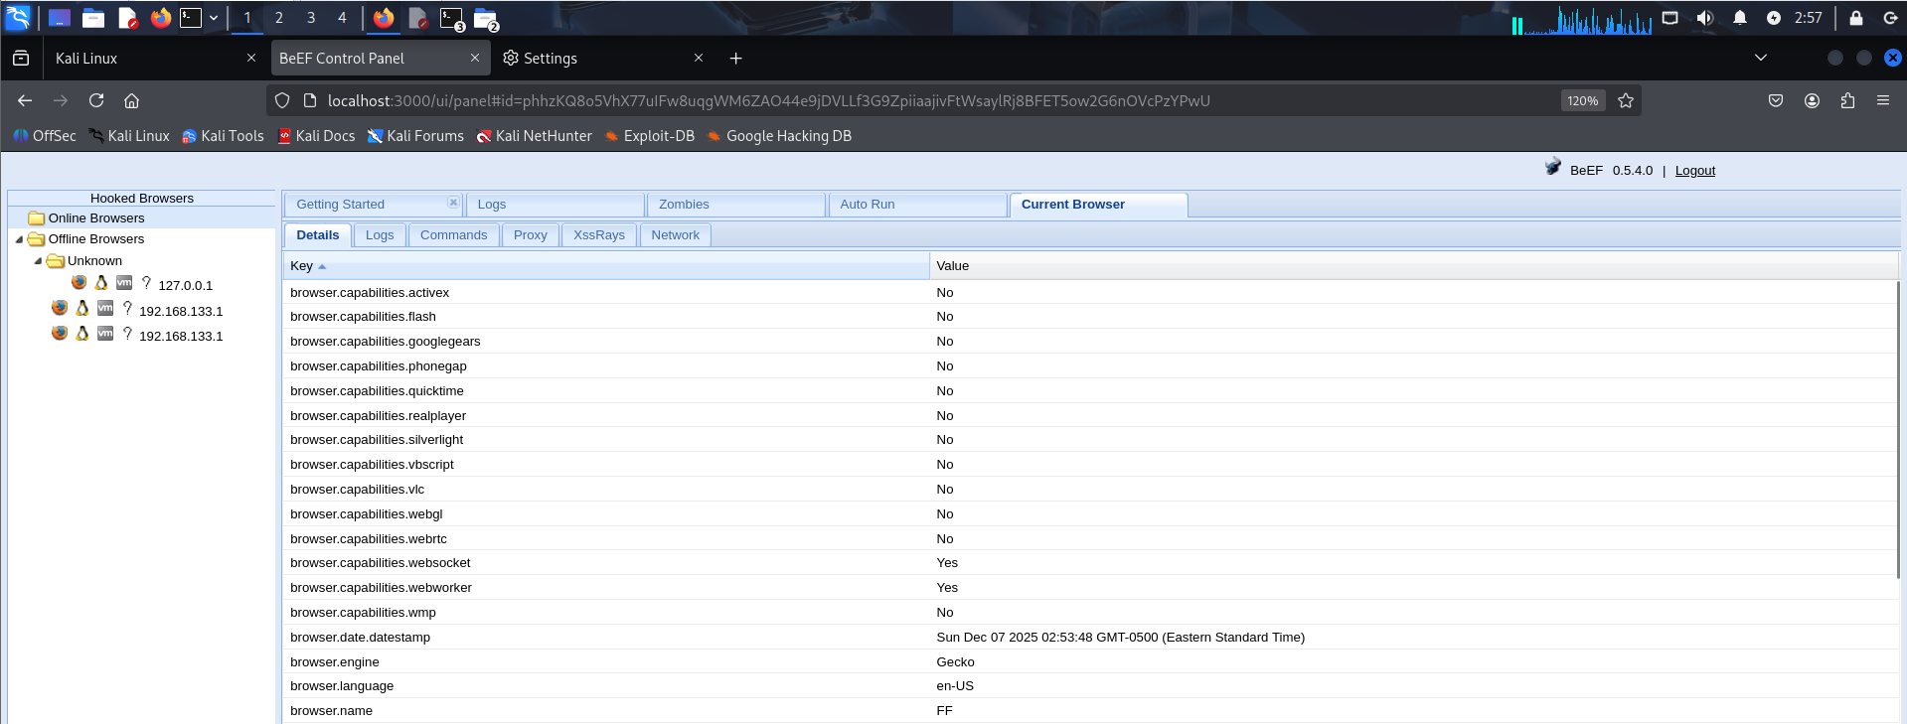
Also, you can educate the week and vulnerable not to click on links from untrusted sources, suspicious emails, or really anything they normally wouldn’t click on.



Sophie was very concerned with getting the project into you early due to you’re announcement and borderline harassed me to get it done, which I had zero issues with, and I think shows her absolute dedication. She worked very hard all weekend to get it into you and due to that got it in early.

As far as I know Jon is a part of our team, as of right now though he is still not enrolled in our team on D2l and I have had no communication with him about his contributions. So, if he does not turn in anything or still doesn’t join our team, please think of me and Sophie as a team of two, PONY OS CLUBZ, the lone soldiers.

I apologize for not making the early deadline of Sunday before three, I was originally working for the deadline on Tuesday and then had to work all weekend so that put a major damper on my progress. As you can see by my GitHub pushes and screenshots most of this project was done at 3am Saturday night so I apologize again if it was not up to snuff. One last meme for the road, Thanks for a great semester, Abe, your class was absolutely my favourite and thanks for making me laugh with your Feedback.
